**PCB parameters and design**

For our measurements we will use a special high frequency **printed circuit board** (PCB) from Rogers Corporation. This PCB has the following parameters

**PCB (printed circuit board) parameters:**

 mm – thickness of the dielectric

 µm or  mm – thickness of the copper layers

 − the dielectric constant of PCB

 − effective dielectric constant for the wave (the wavelength is  mm for 6 GHz)



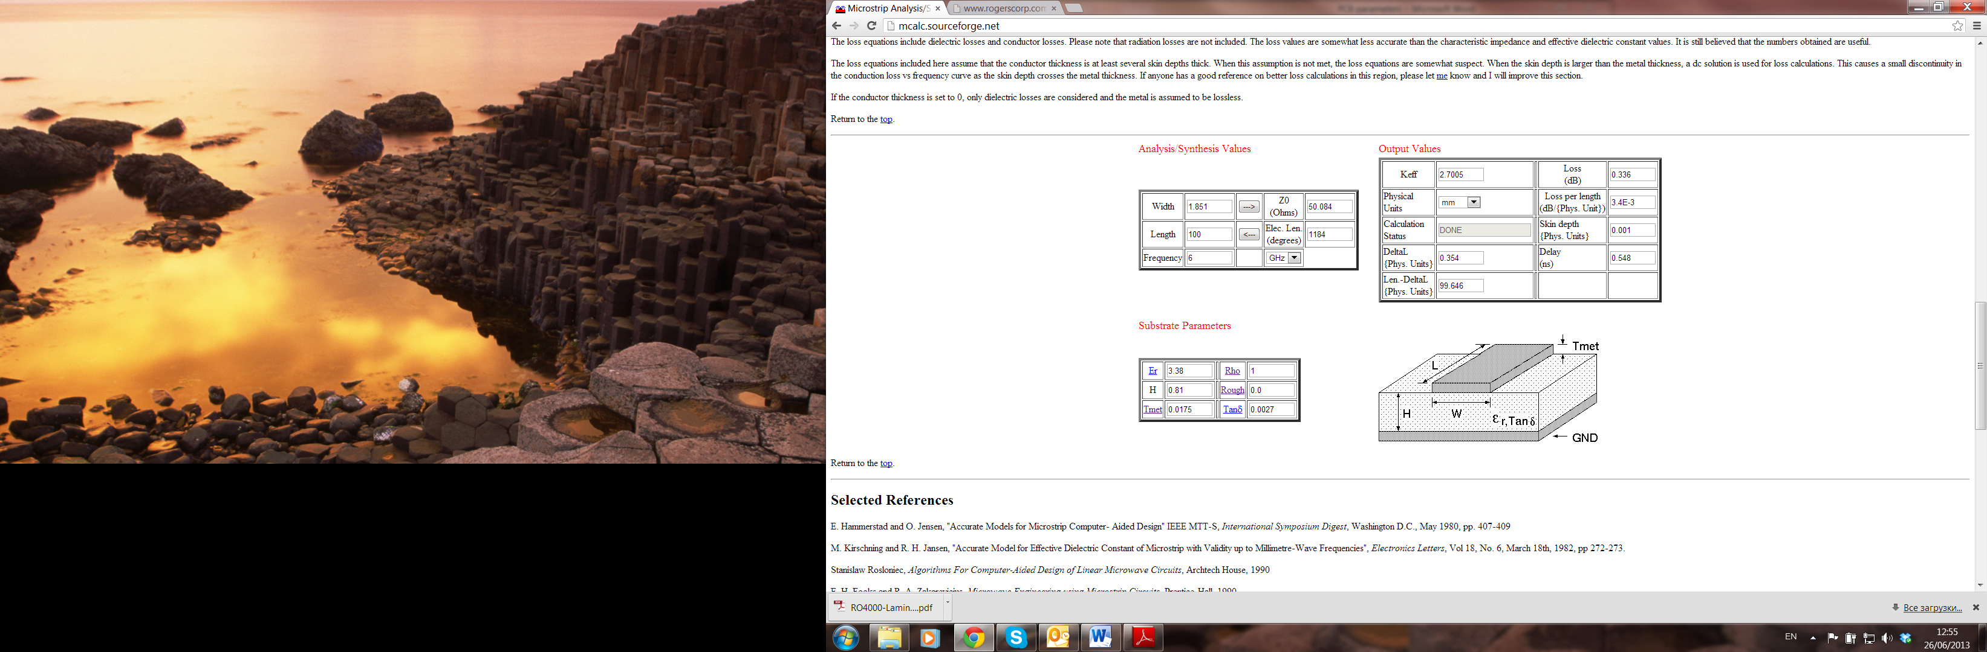

<http://mcalc.sourceforge.net/>

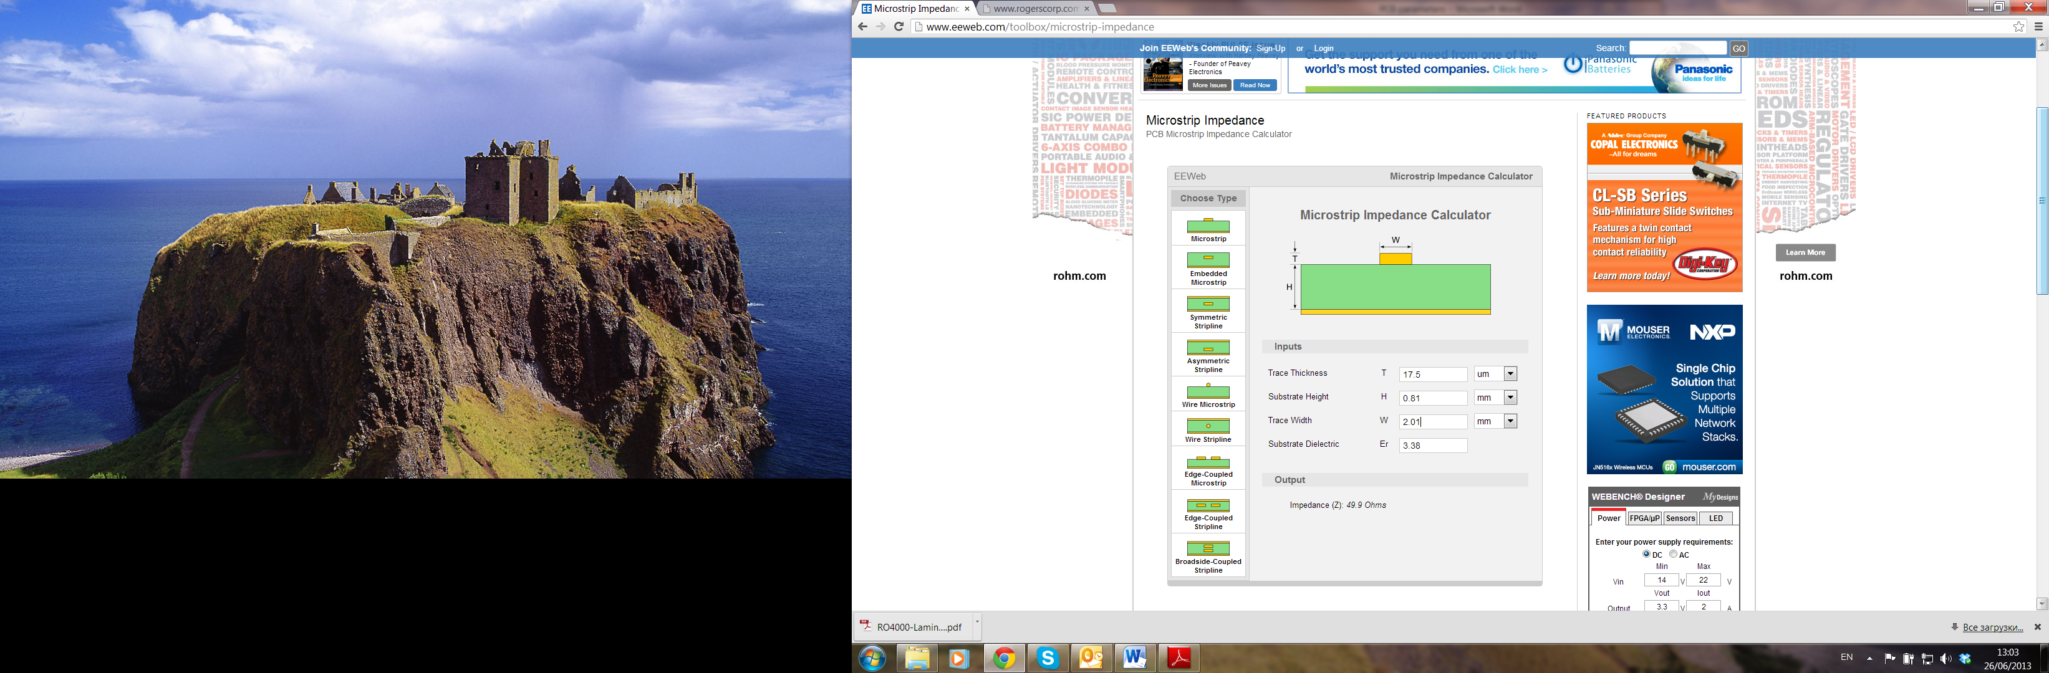

<http://www.eeweb.com/toolbox/microstrip-impedance>

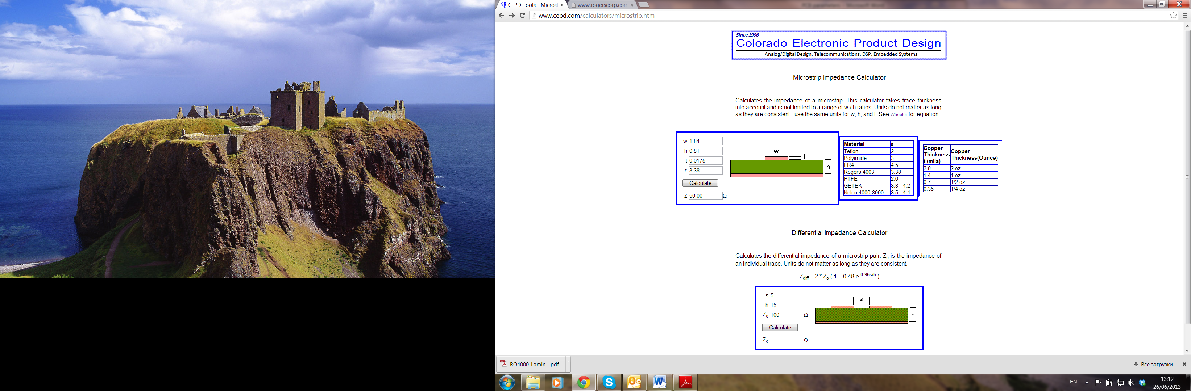

<http://www.cepd.com/calculators/microstrip.htm>

To make a stripe on PCB, we will use the positive photoresist spray and the dedicated developer from Farnell:

<http://uk.farnell.com/electrolube/pdn250ml/photoresist-developer/dp/130540>

<http://uk.farnell.com/electrolube/prp200/photoresist-positive/dp/130552?Ntt=photoresist+spray>